**Batch: Roll No.:**

**Experiment / assignment / tutorial No._______**

**Grade: AA / AB / BB / BC / CC / CD /DD**

**Signature of the Staff In-charge with date**

**Experiment No.:5**

|  |
| --- |
| **TITLE:** Flow control Mechanism: Selective Repeat ARQ Sliding Window Protocol using Socket programming |

**__________________________________________________________________________**

**AIM:** Implementation of Flow Control Mechanism: Stop and Wait ARQ / Go-Back- N

/ Selective Repeat Sliding Window Protocol ARQ using sockets.

**Expected Outcome of Experiment:**

**CO:**

**__________________________________________________________________________**

**Books/ Journals/ Websites referred:**

1. A. S. Tanenbaum, “Computer Networks”, Pearson Education, Fourth Edition
2. B. A. Forouzan, “Data Communications and Networking”, TMH, Fourth Edition

__________________________________________________________________________

**Pre-Lab/ Prior Concepts:**

Java Socket Programming, Flow Control, Go-Back-Stop and Wait

**__________________________________________________________________________**

**New Concepts to be learned:** Window Flow Control **__________________________________________________________________________**

**Design of Go-Back-N ARQ**

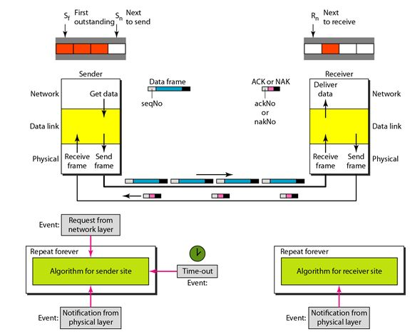

1. Take data from user about how many bit windows is case of go back n and selective repeat.
2. Generate frames randomly and show the transmission
3. Generate the random number for the frame to be lost.
4. For Go – Back – N transmit all the frames after that number till max number
5. For Selective repeat transmit the selected frame which is not received by the receiver.

**IMPLEMENTATION: (**printout of code)

**CONCLUSION:**

**Post Lab Questions**

1. Compare Go-Back-N and Stop and Wait.
2. What is Flow Control and why it is necessary?
3. The maximum window size for data transmission using the selective reject protocol with n-bit frame sequence numbers is  
   a) 2n            b) 2n-1                    c) 2n-1                   d)2n-2

**Date: __________ Signature of Faculty In-charge**